Title: System Design

Course title: IOT Laboratory

Course code: CSE-460
4th Year 1st Semester Examination 2025

Date of Submission: 03/May/2026

Submitted to-

Dr. Md. Ezharul Islam, B.SC.(JU), M.ENGG.(JAPAN), PHD(JAPAN)
Professor
Department of Computer Science and Engineering
Jahangirnagar University

&

Samsun Nahar Khandakar
Assistant Professor
Department of Computer Science and Engineering
Jahangirnagar University
Savar, Dhaka-1342

Class Roll | Exam Roll | Name
383 | 210903 | Abdullah Nazmus-Sakib
379 | 210899 | Shah Sultan
391 | 210911 | Md Khaled Mahmud

Chapter 7: System Design

7.1 System Architecture Design
The system architecture of the IoT-Based Smart Patient Turning and Bed Monitoring System is designed using a layered approach to ensure modularity, scalability, and real-time responsiveness.
The architecture consists of the following layers:

1. Sensing Layer
This layer is responsible for collecting real-time physical data from the patient and environment.
- Pressure Sensors (FSR / Load Cell): Placed under different sections of the mattress to detect body pressure distribution.
- DHT22 Sensor: Measures temperature and humidity around the patient.
These sensors continuously capture raw analog/digital signals.

2. Processing Layer
- The ESP32 microcontroller acts as the core processing unit.
- It performs:
  - Sensor data acquisition
  - Data filtering and preprocessing
  - Time-based immobility tracking
  - Decision-making for alert triggering

3. Communication Layer
- ESP32 uses Wi-Fi module to transmit data.
- Data is sent to cloud platforms such as:
  - Firebase
  - Blynk IoT
This layer ensures real-time data availability for remote monitoring.

4. Application Layer
- Mobile application/dashboard displays:
  - Pressure values
  - Temperature & humidity
  - Alert status
- Caregivers receive notifications in real-time.

5. Alert & Actuation Layer
- Buzzer: Provides local alerts.
- Optional Servo Motor: Enables automatic bed tilting for patient repositioning.

7.2 Block Diagram Explanation

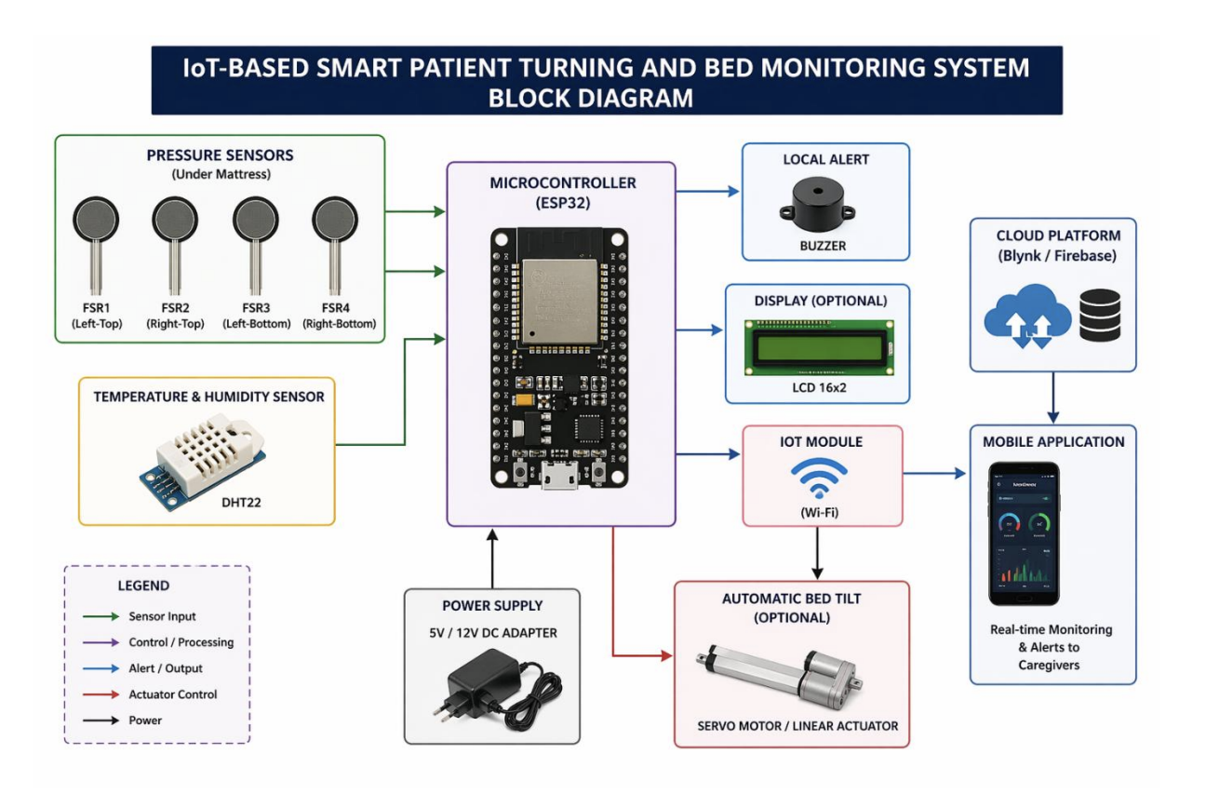
As shown in the block diagram , the system integrates multiple components into a unified workflow.

Key Functional Flow:
- Pressure and environmental data are collected via sensors.
- Data is sent to ESP32 for processing.
- Processed data is:
  - Sent to cloud
  - Used for decision-making
- If abnormal conditions are detected:
  - Buzzer is activated
  - Notification is sent to mobile app

Key Components:
- Input: Pressure sensors, DHT22
- Controller: ESP32
- Output: Buzzer, LCD (optional), Mobile App
- Communication: Wi-Fi module

7.3 Circuit Design

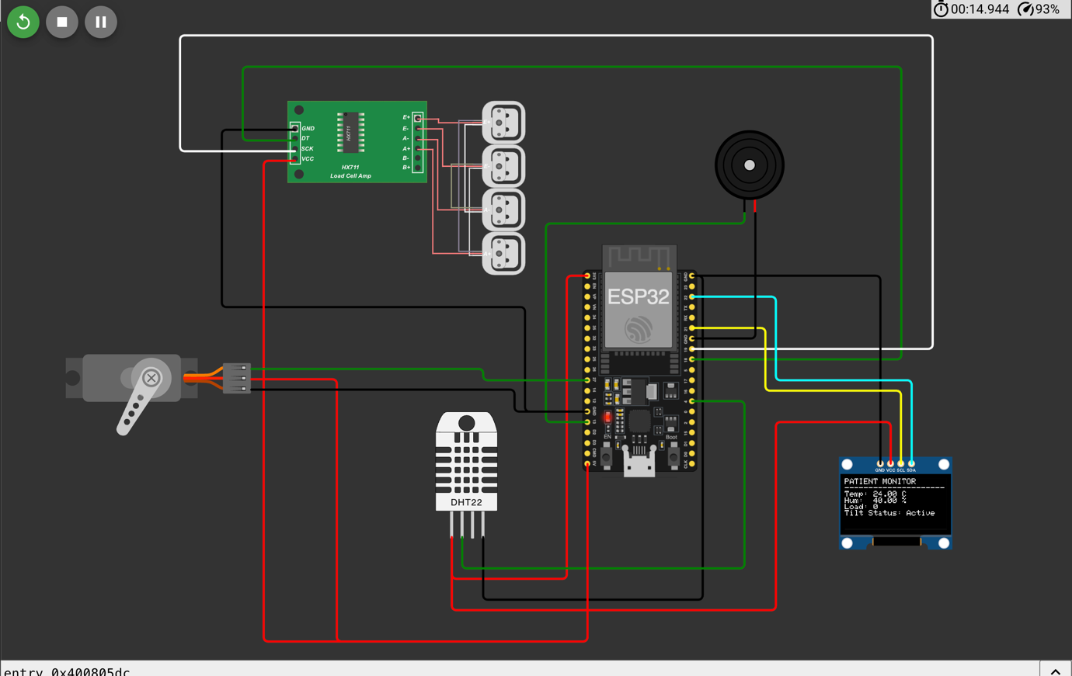
According to the circuit diagram , the hardware connections are implemented as follows:

Sensor Connections:
- FSR Sensors → Connected to ESP32 ADC pins (analog input)
- DHT22 → Connected to digital GPIO pin

Output Connections:
- Buzzer → Connected to GPIO output pin
- LCD Display (optional) → Connected via I2C interface

Power Supply:
- ESP32 powered by 5V adapter
- Sensors operate at 3.3V

7.4 Data Flow Design
The system follows a continuous real-time data flow:

Step-by-Step Data Flow:
- Sensors collect pressure, temperature, and humidity data.
- ESP32 reads sensor values at regular intervals.
- Data is processed and analyzed.
- Decision logic checks:
  - If patient is immobile for threshold time (e.g., 2–3 hours)
- If condition is met:
  - Alert is triggered
- Data is uploaded to cloud
- Mobile app displays real-time updates

7.5 Algorithm Design
The system uses a rule-based algorithm for monitoring:

Algorithm Steps:
- Initialize sensors and Wi-Fi connection
- Continuously read sensor values
- Calculate pressure distribution
- Track time duration of same position
- IF (time > threshold):
  - Trigger buzzer
  - Send alert notification
- Upload data to cloud
- Repeat loop

7.6 Database Design (Cloud Storage)
The cloud database (Firebase/Blynk) stores:

Data Fields:
- Patient ID
- Timestamp
- Pressure values (multiple sensors)
- Temperature
- Humidity
- Alert status

Features:
- Real-time synchronization
- Historical data tracking
- Remote access

7.7 User Interface Design
The mobile application provides:

Dashboard Features:
- Live pressure monitoring
- Temperature & humidity display
- Alert notification system
- Patient status (Normal / Alert)

UI Characteristics:
- Simple and user-friendly
- Real-time updates
- Accessible for caregivers

7.8 Power Management Design
- System uses 5V/12V regulated power supply
- ESP32 regulates to 3.3V internally
- Efficient power usage ensures:
  - Continuous monitoring
  - Low energy consumption

7.9 System Constraints & Design Considerations
- Real-time processing requirement
- Sensor accuracy and calibration
- Stable internet connectivity
- Low-cost hardware design
- Patient safety and reliability

Summary of System Design
The system design integrates:
- Hardware (sensors + ESP32)
- Software (algorithm + cloud)
- Communication (Wi-Fi)
- User interface (mobile app)
This ensures a complete IoT-based healthcare monitoring solution that is:
- Real-time
- Automated
- Scalable
- Cost-effective

